# APPENDIX 2: Parental Information

**Transition from Year 6 to Year 7**

**Aim of the project**: toembed a model of working together to further improve the transition of all pupils

**Autumn Term 2024**

Review of transition for individual pupils informs school planning and provision and system development

**Spring Term 2024**

The Hartlepool Transition Planning Profile Tool (TP-PT) is completed.

This tool has been developed to support early identification of those pupils at risk of not making a successful transition. Parents and pupils are central to the process of completion. Parents will be asked to consent to the sharing of information with secondary schools at an earlier point in the year than has been the case. This will allow for planning on a cohort, group and individual level.

**Summer Term 2024**

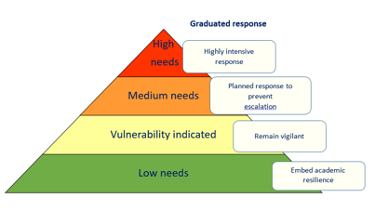

**High needs pupils**: person-centred planning meetings to promote academic resilience and build on protective factors. Academic resilience means students achieving good educational outcomes despite experiencing challenges in their lives. Parents will be a key part of person-centred planning meetings and will be fully involved and informed.

**Medium and low needs pupils:** enhanced conversations between primary and secondary schools to help the secondary schools better understand the pupils and plan appropriate provision.

**Universal:** Schools will be offered materials to support transition as part of the curriculum. Improved staff awareness of academic resilience and protective factors improves outcomes for all.

**Induction activities within the secondary schools for children at all levels will be better tailored to meet the needs of all. Planning for autumn term will be better informed.**