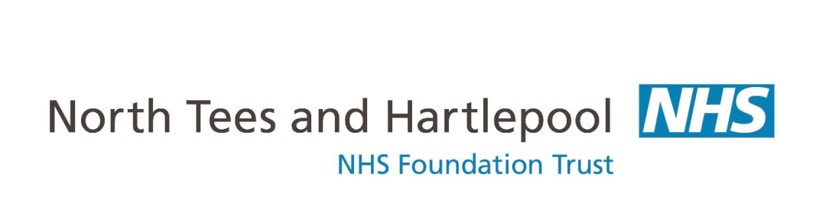

**Out of Hospital Care**

**Audiology Department**

Thanks Audiology

Dear Parent/Guardian,

The Audiology team routinely test children’s hearing when they are in their reception year in school, and we will be seeing your child now they are in Reception/Year 1.

In order to ensure that using headphones on your child is safe, it is important that we are made aware if he or she has had a magnetic shunt fitted into the brain. If your child has had brain surgery and you are unsure if their shunt is magnetic, you will need to contact the paediatrician who deals with your child’s care for clarity.

To maintain the safety of all children, **a hearing test will only be carried out if your child returns the slip of paper at the bottom of this letter to school before** – **Tuesday 26th April 2022. The test will take place on Wednesday 4th May 2022.**

If you have any questions about the hearing screening test please feel free to contact us on 01429 522768

Yours Sincerely

**The Audiology Team**

**Please consider the questions carefully when answering**

|  |  |  |  |  |
| --- | --- | --- | --- | --- |
| child’s Full Name |  | | | |
| Child’s address |  | | | |
| Child’s Date of Birth |  | school |  | |
| Has your child ever had brain surgery? | YES | NO | | Don’t Know |
| If yes, does your child have a shunt in their brain? | YES | NO | | Don’t Know |
| If yes, Is the shuntMagnetic? | YES | NO | | Don’t Know |
| I give consent for my child (named above) to have their hearing tested by the Audiology Team. I am sure that my child does not have a magnetic shunt fitted in his/her brain. | Name Signature  Parent / Guardian (delete as appropriate)  Telephone number in case of query | | | |

|  |  |  |  |  |  |  |  |
| --- | --- | --- | --- | --- | --- | --- | --- |
| **For use by Hearing screener only** | | | | | | | |
| 1st screen date |  | Pass |  | Unsatisfactory |  | Absent |  |
| 2nd screen date |  | Pass |  | Unsatisfactory |  | Absent |  |