Year 2 |  |  |  | Autumn 2
English |  |  |  | Core texts
In English, we are writing simple sentences, which includes a capital letter and full stop. We will be extending sentences using ‘and’. We will identify nouns and adjectives and use them to create noun phrases in our description writing. We will read together a range of fiction and non-fiction texts in our reading lessons. We will also have a spelling lesson each day focusing on different which will help with our reading and spelling. |  |  |  | 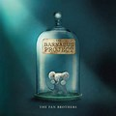  Core Texts:  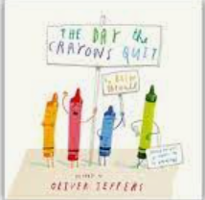  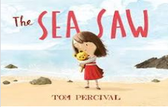
Maths |  |  |  | Number facts
In Maths, we will investigate money. We will look at pounds and pence and add and subtract money from the same units. We will also give change and solve problems in the context of money. We will learn about fractions and find, name, and write fractions ½, 1/3,1/4, 2/4, 3/4 of a length, shape, set of objects or quantity.  We will look at the properties of 2D and 3D shapes. |  |  |  | We will be counting in 2s backwards.
Science
In science, we will be looking at animals including humans. We will learn about at why exercise is important and what it does to our body. We will look at hygiene and have a visit from a dentist.
History |  |  | Design and Technology
In History we will be learning about the Great of Fire of London. We will look at London in 1666, how the fire started and then spread and why. We will look at the effects of the fire had and how London was rebuilt. |  |  | In Design & Technology we will be making Diwali Mango Smoothie and designing and making a Great Fire of London sliding picture.
Physical Education |  |  | Computing
We will be developing our skills for Invasion Games |  |  | We will explore creating media – digital photography. We will also continue our basic skills.
Personal, Health, Social Education and Relationships and Sex Education |  | Religious Education |  |  | Music
We will look at Celebrating differences in our society. |  | Why is light important at Christmas? |  |  | Singing and percussion – Tees Valley Music Service

