Year 2 | 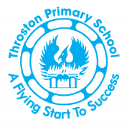 |  |  | Spring 1
English |  |  |  | Core texts
In English, we are writing simple sentences, which includes a capital letter and full stop. We will be extending sentences using ‘and’. We will identify nouns and adjectives and use them to create noun phrases in our description writing. We will read together a range of fiction and non-fiction texts in our reading lessons. We will also have a spelling lesson each day focusing on different which will help with our reading and spelling. |  |  |  | 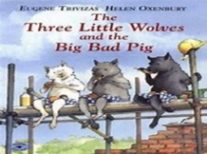  Core Texts:  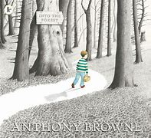
Maths |  |  |  | Number facts
In Maths we will use place value and number facts to solve problems. We will use addition and subtraction to solve one step problems. We will also choose and use appropriate standard units to estimate and measure length/height in any direction (m/cm); mass (kg/g); temperature (°C); capacity (litres/ml) to the nearest appropriate unit, using rulers, scales, thermometers and measuring vessels. |  |  |  | We will be counting fluently in 10s forwards and backwards
Science
In science, we will be looking at Materials. We will identify and compare the suitability of a variety of everyday materials, including wood, metal, plastic, glass, brick, rock, paper, and cardboard for uses. We will investigate and compare the suitability of a variety of everyday materials.
Geography |  |  | Art
In Geography, we will explore hot & cold places. We will identify them on a map, look at their features and the animals that live there. |  |  | The focus is expressive painting. We will be looking at the work of Charlie French and Vincent Van Gough.
Physical Education |  |  | Computing
Dance with Karen Liddle School of Dance |  |  | We will be Programming (Robot Algorithms)
Personal, Health, Social Education and Relationships and Sex Education |  | Religious Education |  |  | Music
We will look at our Dreams and Goals |  | Why is the Bible special to Christians? We look at what the bible is and bible stories.

