Year 2 | 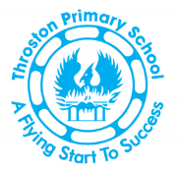 |  |  | Spring 2
English |  |  |  | Core texts
In English, we are writing simple sentences, which includes a capital letter and full stop. We will be extending sentences using ‘and’. We will identify nouns and adjectives and use them to create noun phrases in our description writing. We will read together a range of fiction and non-fiction texts in our reading lessons. We will also have a spelling lesson each day focusing on different which will help with our reading and spelling. |  |  |  | 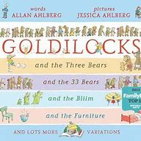  Core Texts:
Maths |  |  |  | Number facts
In Maths we will be solving problems using multiplication and division, sometimes with remainders. We will learn about fractions, recognising, finding and naming fractions of area, sets of objects and quantities, and introducing thirds. We will also look at position and direction and use language to describe position, direction, and movement, distinguishing between a rotation and right angle turns, clockwise and anticlockwise and movement in a straight line. |  |  |  | We will be counting fluently in 5s forwards
Science
In science, we will be looking at Materials. We focus on recycling and the effects plastic has on the environment
Geography/History |  |  | Art/Design & Technology
Physical Education |  |  | Computing
Gymnastics with Shelley Walton from Hartlepool Gymnastics Club |  |  | We will be learning about, Data and Information - Pictograms
Personal, Health, Social Education and Relationships and Sex Education |  | Religious Education |  |  | Music
Valuing Difference |  | Why is the Bible special to Christians? We will look at St Francis of Assisi. We will learn how Christians celebrate Easter and the objects used. We will also look at how they remember Good Friday and Easter Sunday. |  |  | Tees Valley Music Service - percussion

